Laboratory work 5. PWM modulator

Schematics

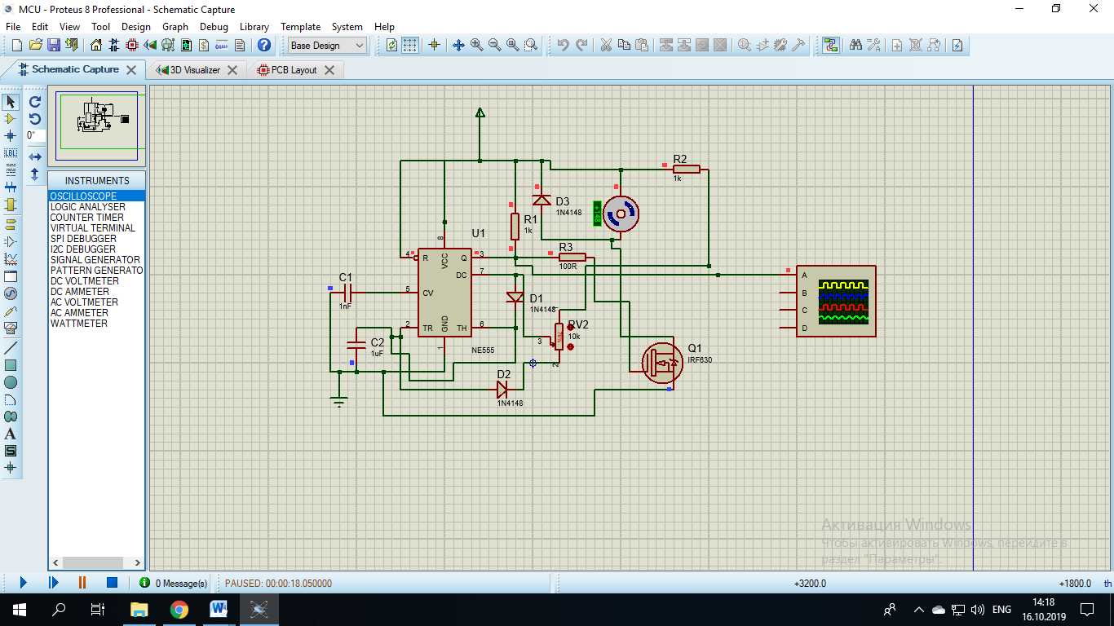

PCB

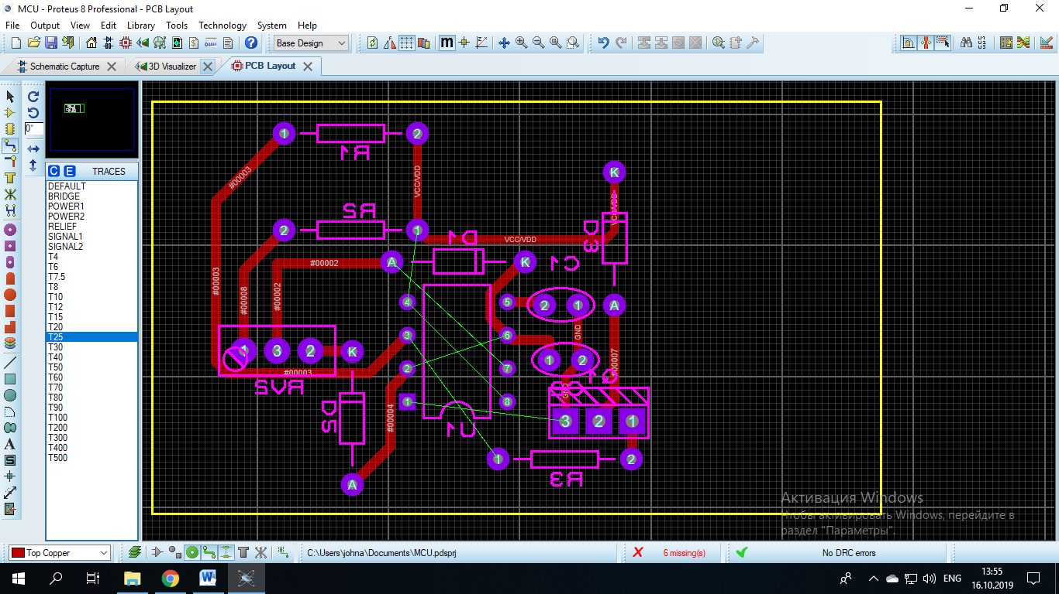

3D view

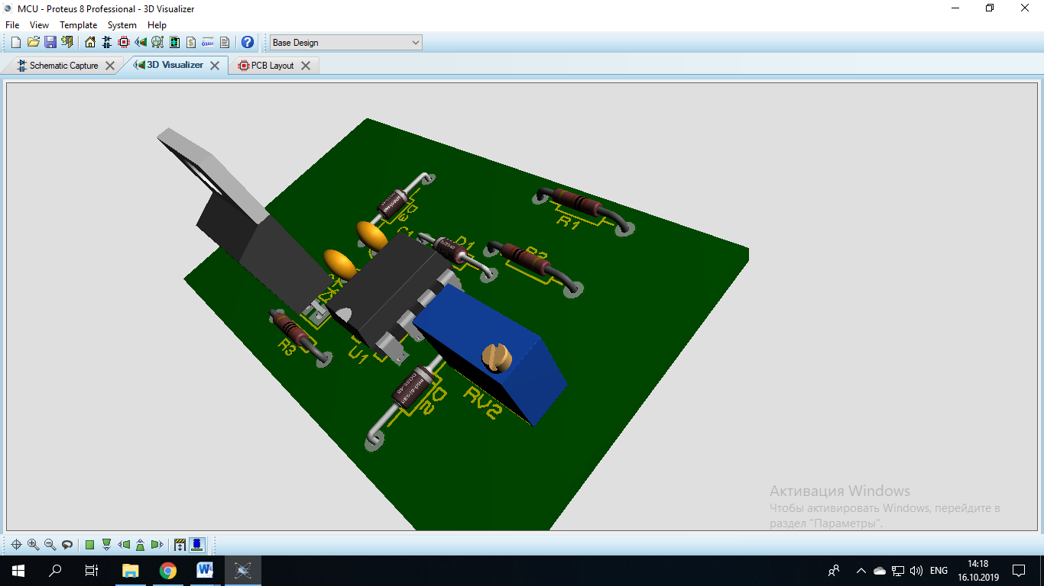

Questions

1. What is PWM modulation? How the PWM modulation could be used?
2. How does the NE555 microchip works?